Table of Contents

Introduction 4

Assumption 4

Data Import 4

Data Exploration 5

QUESTION 1 - What drives people to choose not to keep their jobs at the company? 7

Analysis 1.1: How many employees voluntarily retired 7

Analysis 1.2: How many employees involuntarily retired 7

Analysis 1.3: Summary of termination reason 9

Analysis 1.4: Highest reason employee being terminated 9

Analysis 1.5: What are the average age employees retired voluntarily 10

Analysis 1.6: What is the average length of service of those retired employee 11

Analysis 1.7: The maximum length of service and minimum length of service of retired employee 11

Analysis 1.8: The average age of current active employee 12

Analysis 1.9: Correlation between average age of current active employee and retired employee 13

Analysis 1.10: The rate of retirement 13

Analysis 1.11: The rate of retirement in head office 14

Analysis 1.12: The rate of retirement in stores 15

Analysis 1.13: What is the estimated amount of retirement in the upcoming 5 years 16

Justification 17

Question 2 What is the cause of the employee's resignation and what position did they hold? 18

Analysis 2.1: The total number of resignations 18

Analysis 2.2: The percentage of resignation 18

Analysis 2.3: The average age of resignation 19

Analysis 2.4: The highest and lowest age of resignation 19

Analysis 2.5: The average number of resignations of each age 20

Analysis 2.6: Which age has the highest amount of resignation 20

Analysis 2.7: The average number of resignation per year 21

Analysis 2.8: What is the amount of resignation per year 22

Analysis 2.9: In 2012, which age group has the highest termination count 23

Analysis 2.10: Which position has the highest resignation count for employee age 30 24

Question 3 – The underlying reason leading to high termination count in 2014 25

Analysis 3.1: How many employees' jobs are being terminated every year 25

Analysis 3.2: Which year has the greatest number of terminations 27

Analysis 3.3: The reason resulting in the amount of termination in 2014 27

Analysis 3.4: The correlation between termination and layoff 28

Analysis 3.5: The average age being layoff in 2014 29

Analysis 3.6: The highest age as well as lowest age being layoff 29

Analysis 3.7: The average period served by those employees that are laid off 30

Analysis 3.8: The highest as well as lowest period served by those employees that are laid off 31

Analysis 3.8: Total number of employees in each department in 2014 31

Analysis 3.9: The number of terminations of each department in 2014 33

Analysis 3.10: Department with highest and lowest amount of termination in 2014 34

Analysis 3.11: The amount of employee that served for lesser than 5 years and which department do they belong to 35

Justification 36

Question 4 - What is the relationship between gender and the working status of employees? 37

Analysis 4.1: Number of male and female employee 37

Analysis 4.2: Gender ratio 37

Analysis 4.3: The number of active male and female employees 39

Analysis 4.4: The number of terminated male and female employees 40

Analysis 4.5: Male and female voluntarily retirement rate 41

Analysis 4.6: Male and female involuntarily retirement rate 42

Analysis 4.7: Termination count of female employee per year 43

Analysis 4.8: Number of active females 44

Analysis 4.9: What factor contributes to female termination count 45

Analysis 4.10: What is the reason for termination for age 30 female 46

Analysis 4.11: What is the reason for termination for age 65 female 47

Analysis 4.12: Termination count of male employee per year 48

Analysis 4.13: Number of active males in existing age group 49

Analysis 4.14: What factor contributes to male termination count 50

Analysis 4.15: What is the reason for termination for age 21 Male 51

Analysis 4.16: What is the reason for termination for age 60 Male 52

Justification 53

Extra Features 54

Conclusion 54

# Introduction

I was assigned this project to analyze the problems in the human resources department. This analysis is about the position of the employee and attribution, and all components was investigated and analyzed to find the hidden problem and possible reasons of the problem. The given dataset has 49653 rows of data. A variety of analyzing methodologies and visualization have been employed to provide a greater understanding of the difficulties encountered in the human resource department. Along with the analysis, justification is given for potential reasons why that problem may have happened. For the study to be as accurate as possible, the dataset was imported and preprocessed before it was used.

# Assumption

There were a number of presumptions made about how the data would be prepared, analyzed, and documented. The first presumption made during the acquisition of the data is that not all the provided attributes will be utilized and required for the analysis. This is because redundant and inaccurate data might result from the use of superfluous data. Additionally, it is expected that all the information provided is correct and sufficient to analyze the problems encountered in the human resources department during the dataset creation process. It is considered that the analysis process can be made simpler by developing questions pertaining to the attributes. Additionally, it is believed that providing the most thorough analysis possible for each query will improve the reliability of the analysis and conclusions drawn regarding the problems the human resources department faces. Regarding the documentation procedure, it is presumed that the organization has little knowledge of visualization analysis. Therefore, to ensure that each analysis produced by visualization and tabulation is fully understood, a thorough explanation of the analysis has been provided.

# Data Import

The initial stage in the process of analyzing the provided data was to import the dataset into an analytical application like R Studio. To import, I have utilized the read.csv() function. Then, to provide a tidy and accurate visualization of the data set, I utilized the View() method. The output is display in a new tab as shown as figure 2.

Figure

Output

Figure

# Data Exploration

Data exploration was done before the data was analyzed. The goal of this approach is to provide a more comprehensive understanding of what to anticipate in the analysis and where to start. I started by reviewing the current column heading and changing it to suit my preferences. Following that, I attempted to determine the total number of rows and columns in this dataset. Lastly, I made a summary of the entire dataset.

Figure

Figure

Figure

# QUESTION 1 - What drives people to choose not to keep their jobs at the company?

## Analysis 1.1: How many employees voluntarily retired

Figure

Explanation

* Get all the number of rows with the keyword “Voluntary” and display the result

Output

Figure

Explanation

* The total number of voluntarily retired employees are 1270.

## Analysis 1.2: How many employees involuntarily retired

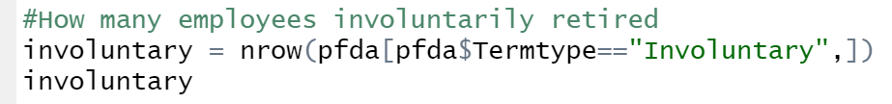

Figure

Explanation

-Get all the number of rows with the keyword “Involuntary’ and display the result

Output

Figure

Explanation

* The total number of involuntarily retired employees are 215.

Figure

Explanation

* Use the obtained earlier, create a pie chart showing the result

Output

Figure

Explanation

* Majority of the employees retired voluntarily while little number of employees retired involuntarily

## Analysis 1.3: Summary of termination reason

Figure

Explanation

* Get all the termination reason from the data set

Output

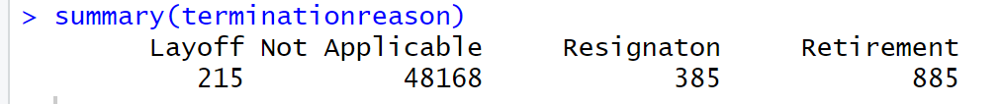

Figure

Explanation

* There are total of three termination type. 215 employees being laid off, 385 employees resign, 885 employees retired and the remaining 48168 employees are marked as not applicable since they do not all fall into this category because they are still working.

## Analysis 1.4: Highest reason employee being terminated



Figure

Explanation

* Get all the termination reason from data set
* Obtain the reason sorting the order from highest to lowest. The 2:4 index is used to avoid having not applicable in the dataset.

Output



Figure

Explanation

* The order is starting from retirement to resignation then to layoff.

## Analysis 1.5: What are the average age employees retired voluntarily

Figure

Explanation

* Get all the employees age that falls under the category of retirement and the reason for retirement is voluntarily
* Calculate the average and round them up into 2 decimal points

Output



Figure

Explanation

* The average age of employees voluntarily retired is 63.64 years old.

## Analysis 1.6: What is the average length of service of those retired employee

Figure

Explanation

* Get all the employees’ length of service under the category of retirement
* Calculate the average and round them up into 2 decimal points

Output



Figure

Explanation

* The average length of service of employees that are retired are 14.15 years.

## Analysis 1.7: The maximum length of service and minimum length of service of retired employee

Figure

Explanation

* Using the variable above, use the max and min function to find out the maximum and minimum length of service

Output

Figure

Explanation

* The maximum length of service of a retired employee is 25 years and the minimum length of service of a retired employee is 8 years.

## Analysis 1.8: The average age of current active employee

Figure

Explanation

* Get the data of all employees age that are still active
* Calculate the average and round them up to 2 decimal points

Output



Figure

Explanation

* The average age of active employees are 41.79 years old.

## Analysis 1.9: Correlation between average age of current active employee and retired employee



Figure

Explanation

* Using the average age of retired and active employees to find the length for average age of active employees till their retirement length.

Output

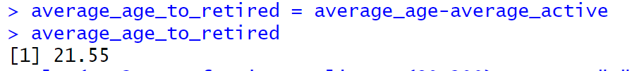

Figure

Explanation

* The average age for active employees to reach their retirement day is 21.55 years.

## Analysis 1.10: The rate of retirement

Figure

Explanation

* Get all the numbers of employees
* Get all the employees that falls under the category of voluntarily retired
* Calculate the rate of retirement

Output

Figure

Explanation

* The overall rate of retirement is 14%

## Analysis 1.11: The rate of retirement in head office

Figure

Explanation

* Get all the employees working in the head office
* Get all the employees that are working in the head office and the ones that are not working in the head office
* Calculate the rate of retirement in the head office

Output

Figure

Explanation

* The rate of retirement in head office is 12%

## Analysis 1.12: The rate of retirement in stores

Figure

Explanation

* Get all the employees working in the stores
* Get all the employees that are working in the stores and the ones that are not working in the stores
* Calculate the rate of retirement in the stores

Output

Figure

Explanation

* The rate of retirement in head office is 3%

Figure

Explanation

Output

Figure

Explanation

* In 2016, there is 183 employees expected to retire. In 2017, there is 114 employees expected to retire. In 2018, there is 109 employees expected to retire. In 2019, there is 105 employees expected to retire. In 2020, there is 121 employees expected to retire.

## Justification

This study is to find out what influence employees’ decisions to retire. Among all employees, 85.52% voluntarily retired while the remaining 14.48% involuntarily retired. The three most frequent factors for terminating an employee are retirement, resignation, and layoff. The most popular explanation among these three is retirement. The average age of those retired employees are 63 years old with an average 14 years of service. In comparison, average age of current active employees are 41 years old and they are expected to work for another 21 years before retiring. Accounting the rate of retirement, the rate in Head Office appears to be significantly higher compared to Stores. One of the causes could be the employees in Head Office, who are on average 63 years old, are overworked and unable to handle the burden. In addition, forecast is done to predict the estimated number of retirements in the upcoming 5 years. Another possible explanation is that the atmosphere at the headquarters is too stressful, and the staff, who are typically over the age of 63, wish to relax and enjoy life. This is important as it enables the organization to anticipate business's workload so they can make sure they have the right number of employees on hand at the appropriate time to handle the volume of work.

# Question 2 What is the cause of the employee's resignation and what position did they hold?

## Analysis 2.1: The total number of resignations



Figure

Explanation

* Get the total number of resignations

Output

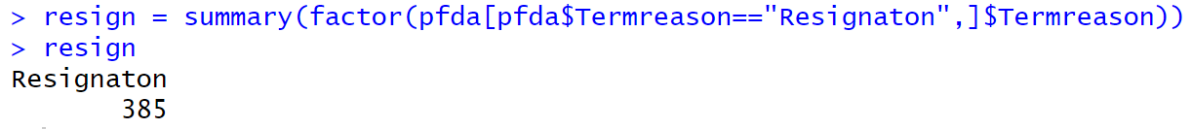

Figure

Explanation

* The total number of resignation count is 385.

## Analysis 2.2: The percentage of resignation



Figure

Explanation

* Use the total number of resignation and total number of employees to find out the rate of resignation

Output



Figure

Explanation

* The resignation rate is 6%.

## Analysis 2.3: The average age of resignation

Figure

Explanation

* Get all the employees age with resignation as their termination reason
* Calculate the average and round it up to two decimal points if there is any

Output

Figure

Explanation

* The average age to resign is 30.0987 years old.

## Analysis 2.4: The highest and lowest age of resignation

Figure

Explanation

* Using data collected from employee resignation age, use the max and min function to find out the maximum and minimum resignation age

Output

Figure

Explanation

* The highest resignation age is 63 years old, and the lowest resignation age is 19 years old.

## Analysis 2.5: The average number of resignations of each age

Figure

Explanation

* Get all the age of employees that resigned
* Calculate the average and round it up to two decimal points if there is any

Output

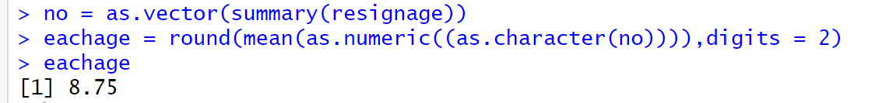

Figure

Explanation

* The average amount of resignation of each age group is 8.75%

## Analysis 2.6: Which age has the highest amount of resignation



Figure

Explanation

* Using data collected from employee resignation age, sort them out in descending order and find out the total number of it.

Output

Figure

Explanation

* The age with the greatest number of resignations is 30 years old, with a total of 75 resignations.

## Analysis 2.7: The average number of resignation per year

Figure

Explanation

* Get the number of resignations per year
* Calculate the average rate of resignation and round it up to two decimal points if there is any

Output

Figure

Explanation

* The average number of resignations among employees are 38.5 per year

## Analysis 2.8: What is the amount of resignation per year

Figure

Explanation

* Create a data frame with year and the number of resignation of that year
* Use ggplot library to create a barchart

Output

Figure

Figure

Explanation

* In 2006, there is 12 employees resigned. In 2007, there is 25 employees resigned. In 2008, there is 26 employees resigned. In 2009, there is 18 employees resigned. In 2010, there is 29 employees resigned. In 2011, there is 69 employees resigned. In 2012, there is 76 employees resigned. In 2013, there is 49 employees resigned. In 2014, there is 55 employees resigned. In 2015, there is 26 employees resigned.

## Analysis 2.9: In 2012, which age group has the highest termination count

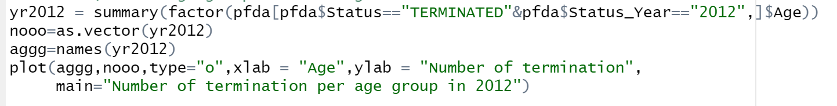

Figure

Explanation

* Get the data of all age group along with their termination count in 2012
* Separate into two variables (one will be the heading, the other will be the data)
* Create a line graph

Output

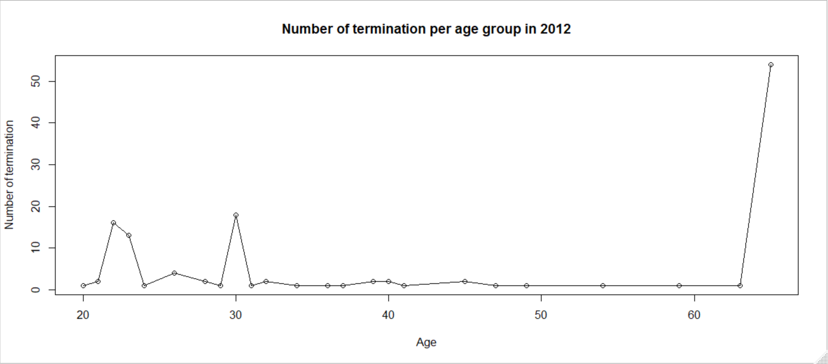

Figure

Explanation

* We can observe that age 65 has the highest termination count followed by age of 30 and 22

## Analysis 2.10: Which position has the highest resignation count for employee age 30

Figure

Explanation

* Find out the job title of those employees at the age of 30 that has resigned
* Convert data into data frame
* Create a bar chart

Output

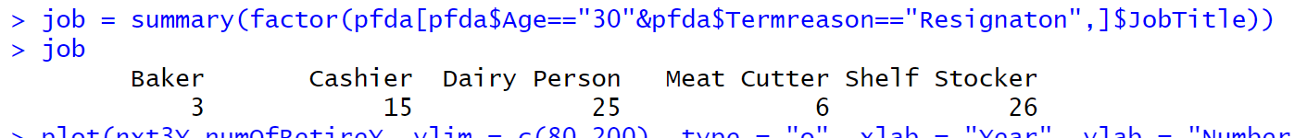

Figure

Figure

Explanation

* The position with the highest resignation is Shelf Stocker, followed by Dairy Person and Cashier.

Justification

The purpose of this study is to discover the reason for the employee's resignation and the position they held. Overall, have been a total 385 numbers of employees that has resigned. The average age of individuals that resigned is 30 years old, with the highest being 63 years old and the lowest being 19 years old. According to data, employees at the age of 30 have the highest rate of resignations, with a total of 75 employees. The average number of resignations is about 8.75 per age group and is 38.5 per year. From figure 50 chart shows, year 2012 has the highest number of resignations with a total of 76 employees. In year 2012, age of 65 has the highest resignation rate followed by age of 30. Majority of the employees age of 30 predominately held positions as Shelf Stocker, Dairy Person, and Cashier. The high rate of resignation in these few positions may indicate that the assigned responsibilities are overly routine or monotonous, which results in lower motivation and leads to resignation. Another explanation can be that they are still young and would like to start a business or change careers somewhere.

# Question 3 – The underlying reason leading to high termination count in 2014

## Analysis 3.1: How many employees' jobs are being terminated every year

Figure

Explanation

* Get the total number of terminations every year
* Create a line graph from ggplot2 library

Output



Figure

Figure

Explanation

* In year 2006, there is 134 employees being terminated. In year 2007, there is 162 employees being terminated. In year 2008, there is 164 employees being terminated. In year 2009, there is 142 employees being terminated. In year 2010, there is 123 employees being terminated. In year 2011, there is 110 employees being terminated. In year 2012, there is 130 employees being terminated. In year 2013, there is 105 employees being terminated. In year 2014, there is 253 employees being terminated. In year 2015, there is 162 employees being terminated.

## Analysis 3.2: Which year has the greatest number of terminations



Figure

Explanation

* Get the year along with each termination count
* Sort it out in descending order to obtain the highest one

Output



Figure

Explanation

* The year with the greatest amount of termination is 2014 with 253 employees.

## Analysis 3.3: The reason resulting in the amount of termination in 2014

Figure

Explanation

* Get all the termination reason in 2014 along with the number of each termination
* [2] is used to display the second highest data as “Not Applicable” doesn’t fall under our requirements

Output

Figure

Explanation

* The most common reason leading to high amount of termination in 2014 is “layoff” with 142 employees

## Analysis 3.4: The correlation between termination and layoff

Figure

Explanation

* Find out the rate of layoff in relation to the total existing termination count

Output

Figure

Explanation

* The percentage of layoffs makes up 56%, while retirement and resignation take up the remaining percentage.

## Analysis 3.5: The average age being layoff in 2014

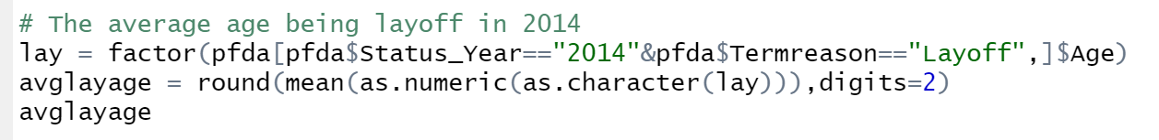

Figure

Explanation

* Find out the age of every employee with the termination reason being “layoff”
* Calculate the average and round up to two decimals if there is any

Output



Figure

Explanation

* The average age employee laid off is 38.22 years old

## Analysis 3.6: The highest age as well as lowest age being layoff

Figure

Explanation

* Finding the highest and lowest age employees got laid off

Output

Figure

Explanation

* The highest age of employees that got laid off is 64 years old and the lowest age of employees that got laid off is 20 years old

## Analysis 3.7: The average period served by those employees that are laid off

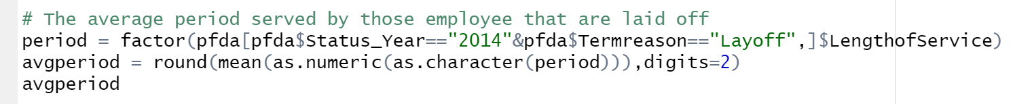

Figure

Explanation

* Acquiring all the length of service relating to those employees that got laid off
* Find the average of it and round it up to two decimals if there is any

Output



Figure

Explanation

* The average length of service of those employees that got laid off is 10.42 years

## Analysis 3.8: The highest as well as lowest period served by those employees that are laid off

Figure

Explanation

* Finding the highest and lowest length of service of employees that got laid off

Output

Figure

Explanation

* The highest length of service of employees that got laid off is 24 years and the lowest length of service of employees that got laid off is 1 years

## Analysis 3.8: Total number of employees in each department in 2014

Figure

Explanation

* Find out all the existing department
* Get the total number of employees in each department

Output

Figure

Explanation

* In Accounting department, there is 6 employees. In Accounts Payable department, there is 3 employees. In Accounts Receivable department, there is 3 employees. In Audit department, there is only 1 employee. In Bakery department, there is 817 employees. In Compensation department, there is only 1 employee. In Customer Service department, there is 1064 employees. In Dairy department, there is 901 employees. In Employee Records, there is 4 employees. In Executive department, there is 10 employees. In HR Technology department, there is 6 employees. In Investment department, there is only 1 employee. In Labor Relations, there is 2 employees. In Legal department, there is only one employee. In Meats department, there is 939 employees. In Processed Foods department, there is 688 employees. In Produce department, there is 736 employees. In Recruitment department, there is 7 employees. In Store Management department, there is 23 employees. In Training department, there is 2 employees.

## Analysis 3.9: The number of terminations of each department in 2014



Figure

Explanation

* Find out all the existing department
* Get the total number of employees that are terminated in each department

Output

Figure

Explanation

* In Accounting, Accounts Payable, Accounts Receivable and Legal department, there is only 1 employee being terminated. In Labor Relations and Training department, there is 2 employees being terminated. In Bakery department, there is 22 employees being terminated. In Customer Service department, there is 98 employees being terminated. In Dairy department, there is 29 employees being terminated. In Employee Records department, there is 4 employees being terminated. In HR Technology, there is 6 employees being terminated. In Meats department, there is 28 employees being terminated. In Processed Foods department, there is 23 employees being terminated. In Produce department, there is 18 employees being terminated. In Recruitment department, there is 6 employees being terminated. In Store Management department, there is 11 employees being terminated.

## Analysis 3.10: Department with highest and lowest amount of termination in 2014

Figure

Explanation

* Find the department with highest and lowest number of terminations count along with the department name
* For highest, [1] is used to show the first result. For lowest, [1:4] is used as there is 4 results with the lowest number of termination count

Output

Figure

Explanation

* Customer Service department has the highest termination count with 98 employees while Accounting, Accounts Payable, Accounts Receivable and Legal department has the lowest termination count with only 1 employee each

## Analysis 3.11: The amount of employee that served for lesser than 5 years and which department do they belong to

Figure

Explanation

* Identify the number of employees that were laid off and had fewer than five years of service, per age group.
* Identify the number of employees that were laid off and had fewer than five years of service, as well as their departments.

Output

Figure

Explanation

* At aged 20, there is 2 employee that got laid off. At aged 21, there is 3 employee that got laid off. At aged 22, there is 9 employee that got laid off. At aged 23, there is 3 employee that got laid off. At aged 24, there is 4 employee that got laid off. At aged 25, there is 5 employee that got laid off. At aged 26, there is 2 employee that got laid off. At aged 27, there is 3 employee that got laid off. At aged 28, there is 6 employee that got laid off. At aged 29, there is 3 employee that got laid off.
* Among those, 1 come from Bakery department, 26 come from Customer Service department, 4 come from Dairy department, 1 come from Meats department, 7 come from Processed Foods department and 1 come from Produce department.

## Justification

Overall, the year with the highest termination count is 2014 with 254 numbers of employees being terminated. The most popular reason for termination among these 254 employees is "layoff," which accounts for 56% of terminations, followed by resignation and retirement. The average age among this group of employees that got laid off is 38.22 years. The highest being 64 years old and the lowest being 20 years old. The average length of service among this group of employees that got laid off is 10.42 years. The longest being 24 years and the shortest being 1 years. There are a total of 20 departments when you explore further into them. The department with the highest number of termination count is Customer Service and lowest number of termination count is Accounting, Accounts Payable, Accounts Receivable and Legal department. With searching employees with length of service less than 5 years, majority are from aged of 23 and Customer Service department continues to have the highest percentage of terminations.

The high number of employees that got laid off at the aged of 64, could indicate that their productivity is low, and they are perhaps not as effective as they once were. Meanwhile, those employees that got laid off at the age of 20, may have failed to live up to standards and criteria set by their managers or produced poor work performance at workplace. According to the data, the department with the greatest number of terminations is customer service. One of the reasons might suggests staff just do not receive the appropriate amount of training they require to be effective and confident in their job performance. As a result, they could not feel comfortable in their role, feel under pressure when communicating with clients, and make mistakes or act improperly. Consequently, their managers are more susceptible to pick up negative feedbacks by clients.

# Question 4 - What is the relationship between gender and the working status of employees?

## Analysis 4.1: Number of male and female employee

Figure

Explanation

* Utilized the table function to display the total number of male and female

Output

Figure

Explanation

* There are a total of 25898 female employees and 23755 male employees

## Analysis 4.2: Gender ratio

Figure

Explanation

* Using the data collected from total number of male and female employees, I have created a 3d pie chart from plotrix package.

Output

Figure

Explanation

* From this chart, female employees occupy 52.16% and male employees occupies 47.84%. As a result, there is more female employee than male employee

## Analysis 4.3: The number of active male and female employees

Figure

Explanation

* Firstly, I collect the data of both male and female employees with active working status.
* After that, I created a horizontal bar chart with data collected

Output

Figure

Figure

Explanation

* From the chart above, we can conclude that there are more active female employees than male employees.

## Analysis 4.4: The number of terminated male and female employees

Figure

Explanation

* Firstly, I collect the data of both male and female employees with terminated working status.
* After that, I created a horizontal bar chart with data collected

Output

Figure

Figure

Explanation

* From this chart, we can conclude that there are more female employees being terminated compared to male employees

## Analysis 4.5: Male and female voluntarily retirement rate

Figure

Explanation

* Get the number of male and female voluntarily retire count
* Find the rate and round it up to decimal point if there is any

Output

Figure

Explanation

* We can tell that there are 468 male employees voluntarily retired and that occupies 37% of the overall workforce. On the other hand, there are 802 female employees voluntarily retired and they share the remaining 63%.

## Analysis 4.6: Male and female involuntarily retirement rate

Figure

Explanation

* Get the number of male and female involuntarily retire count
* Find the rate and round it up to decimal point if there is any

Output

Figure

Explanation

* We can tell that there are 102 male employees involuntarily retired and that occupies 47% of the overall workforce. On the other hand, there are 113 female employees involuntarily retired and they share the remaining 53%.

## Analysis 4.7: Termination count of female employee per year

Figure

Explanation

* Get all the existing age group and the number of terminations of every age group
* Create a line graph to show the output

Output

Figure

Explanation

* We can observe that age 65 has the highest termination count followed by age of 30.

## Analysis 4.8: Number of active females

Figure

Explanation

* Get all the existing age group and the number of employees that are still active of every age group
* Create a bar chart to show the output

Output

Figure

Explanation

* The highest number of female employees that are still active are at the age of 50. The remaining are roughly the same except for low number of active female employee at the age of 19 and 65

## Analysis 4.9: What factor contributes to female termination count

Figure

Explanation

* Identify the reason leading to female termination
* Create a horizontal bar chart with data collected

Output



Figure

Figure

Explanation

* We can tell that the most common reason is retirement with 591 employees, followed by resignation with 211 employees and lastly layoff with 113 employees

## Analysis 4.10: What is the reason for termination for age 30 female

Figure

Explanation

* Get all the termination reason from female employee aged 30
* Create a pie chart showing percentage of each reason

Output

Figure

Explanation

* From this chart, we can conclude that resignation shares the highest percentage followed by layoff.

## Analysis 4.11: What is the reason for termination for age 65 female

Figure

Explanation

* Identify the termination reason from female employee aged 30
* Create a horizontal bar chart to display the result

Output

Figure

Explanation

- Based on this graph, we can deduce that the only reason for a 65-year-old female employee's termination is retirement.

## Analysis 4.12: Termination count of male employee per year

Figure

Explanation

* Get all the existing age group and the number of terminations of every age group
* Create a line graph to show the output

Output

Figure

Explanation

* We can observe that age 60 has the highest termination count followed by age of 21.

## Analysis 4.13: Number of active males in existing age group

Figure

Explanation

* Get all the existing age group and the number of employees that are still active of every age group
* Create a bar chart to show the output

Output

Figure

Explanation

* The highest number of male employees that are still active are at the age of 27. The remaining are roughly the same except for low number of active male employee at the age of 19 to 24 and after 60 years old

## Analysis 4.14: What factor contributes to male termination count

Figure

Explanation

* Identify the reason leading to female termination
* Create a horizontal bar chart with data collected

Output



Figure

Figure

Explanation

* We can tell that the most common reason is retirement with 294 employees, followed by resignation with 174 employees and lastly layoff with 102 employees

## Analysis 4.15: What is the reason for termination for age 21 Male

Figure

Explanation

* Identify the termination reason from male employee aged 21
* Create a horizontal pie chart to display the result

Output

Figure

Explanation

* From this chart, we can conclude that resignation shares the highest percentage followed by layoff.

## Analysis 4.16: What is the reason for termination for age 60 Male

Figure

Explanation

* Identify the termination reason from male employee aged 60
* Create a horizontal bar chart to display the result

Output

Figure

Explanation

* Based on this graph, we can deduce that the only reason for a 60-year-old male employee's termination is retirement.

## Justification

Overall, there are more female employees compared to male employees. The most frequent causes of termination for both male and female employees are retirement, resignation, and layoff. In terms voluntary and involuntary retirement rate, female employees share the higher percentage in both field in comparison to male employees. The most female employees have been terminated at age 65, followed by age 30. Retirement is the sole factor in the termination of 65-year-old female employees. For female employees who are 30 years old, the main causes are resignation and sparse layoffs. On the other hand, male employees between the ages of 21 and 60 had the highest number of terminations. The primary cause of the 60-year-old male employees' termination was retirement. For male employees in the age of 21, resignation is the primary cause, followed by a small number of layoffs. High number of retirements for male aged 60 and female aged 65 indicate that it is time for them to take a break from their demanding working lives or that they simply want to take it easy and enjoy life.

Female employees who left their jobs around the age of 30 may choose to begin a new career in a different industry for a variety of reasons, such as discovering a new passion or not liking their current working environment. However, those who were laid off at the age of 30 might indicate that their level of productivity falls short of what is required in the workplace. Male employees who quit their jobs at age 21 may be considering starting their own businesses or looking into alternative career paths given their youth. Male workers who were laid off at age 21 may have bad work ethic, such as immaturity that results in low production or even poor time management that causes them to be consistently late to work.

# Extra Features

# Conclusion